

|  |
| --- |
|  |

**Atlassian Stash Installation**

**Guide**

# Table of Contents

Table of Contents 2

1. Introduction 3

2. prerequiste 3

3. installation and configuration 3

3.1 **git installation** 3

3.2 **STASH_HOME Configuration** 13

3.3 **STASH installation** 13

3.4 **stash Configuration** 17

# 

# Introduction

**Git repository management your way**

On-premises source code management for Git that's secure, fast, and enterprise grade. Create and manage repositories, set up fine-grained permissions, and collaborate on code – all with the flexibility of your servers.

# prerequiste

**Java**

You will need to install a Java Development Kit (JDK) on your operating system before proceeding with a Stash installation. Please note that Stash requires the full installation of a JDK. It is not enough to run Stash on a Java Runtime Environment (JRE) alone.

**GIT**

Atlassian Stash is the Git repository management solution for enterprise teams. It allows everyone in your organisation to easily collaborate on your Git repositories.

# installation and configuration

## **git installation**



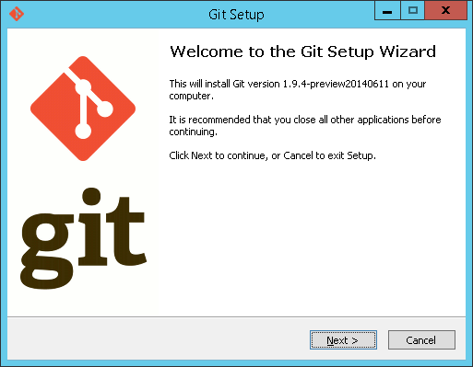

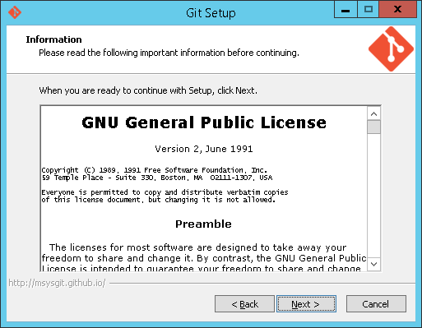

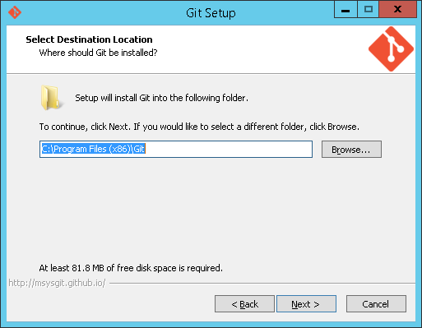

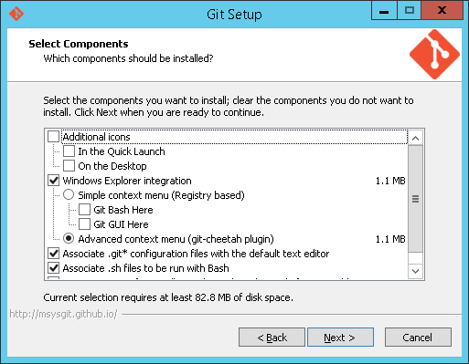

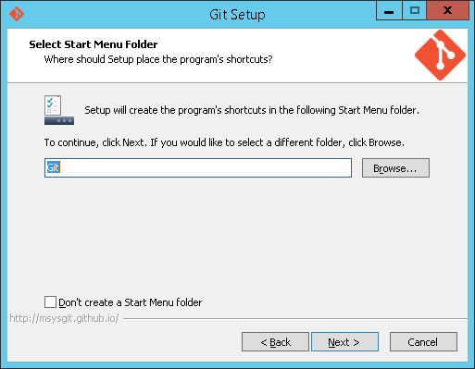

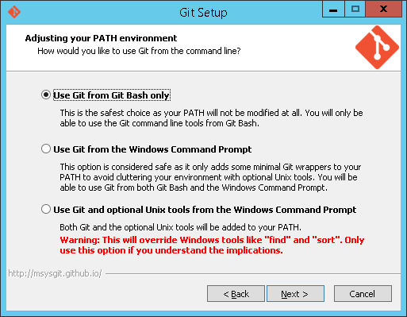

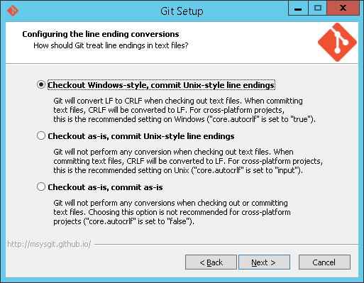

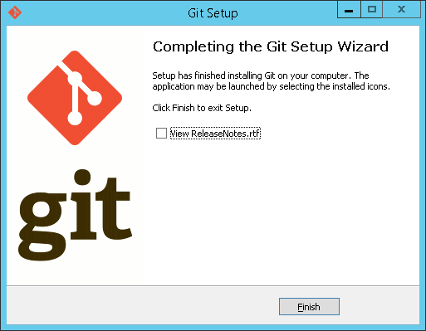

***Prepare your Database for STASH Installation***

* Create Database in **MS SQL Server**

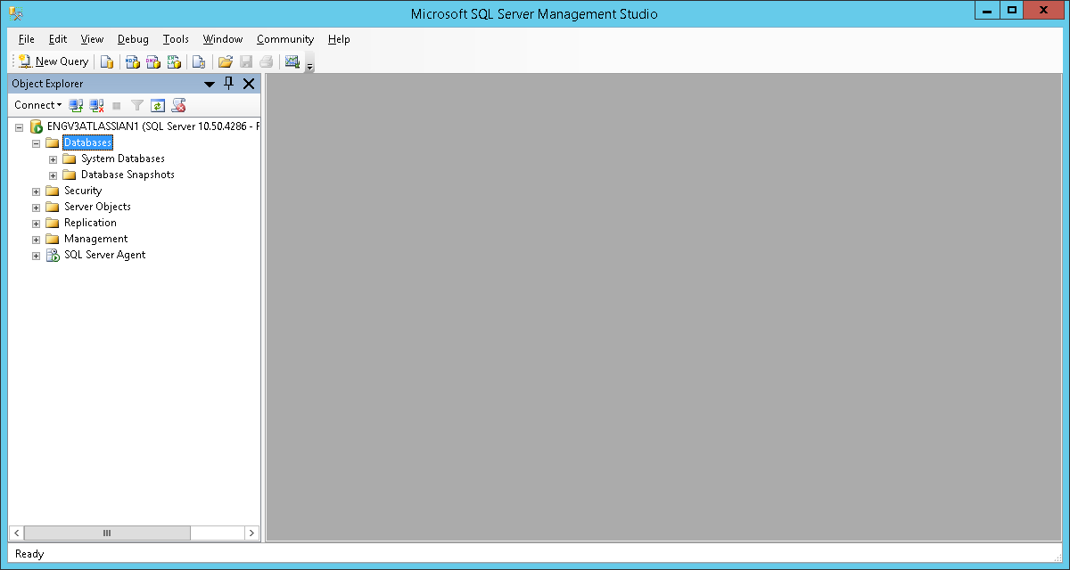

* Go to SQL Server Database and Right click **New Database**, Provide **Database name.**

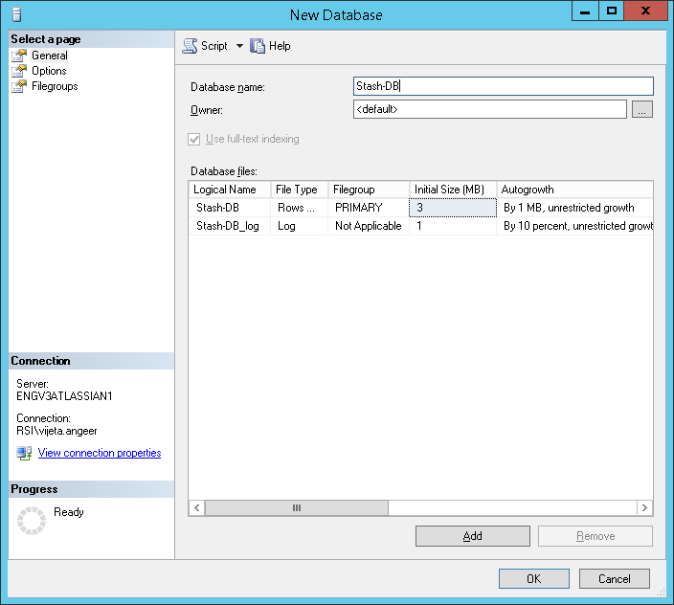

* Go to **Options** and select **Collation** type **Case Sensitive**. Click on **OK.**

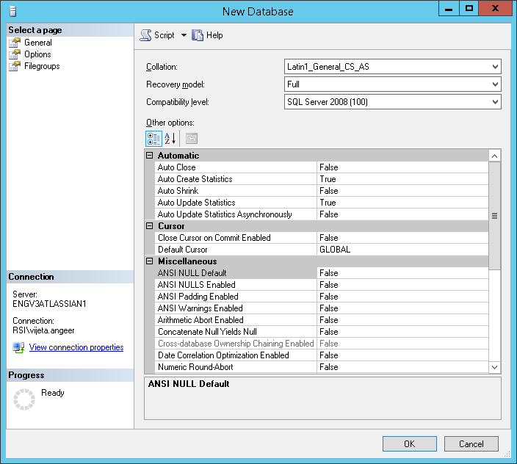

Ensure that the SET NOCOUNT option is turned off. You can do that in SQL Server Management Studio as follows:

Navigate to **Tools**>**Options**>**Query Execution**>**SQL Server**>**Advanced**. Ensure that the **SET NOCOUNT** option is cleared.

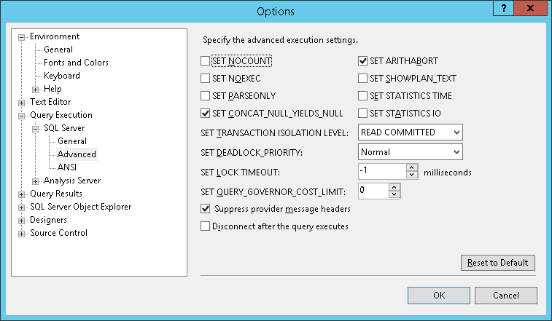

Now, go to the **Server**>**Properties**>**Connections**>**Default Connections** properties box and clear the **no count** option.

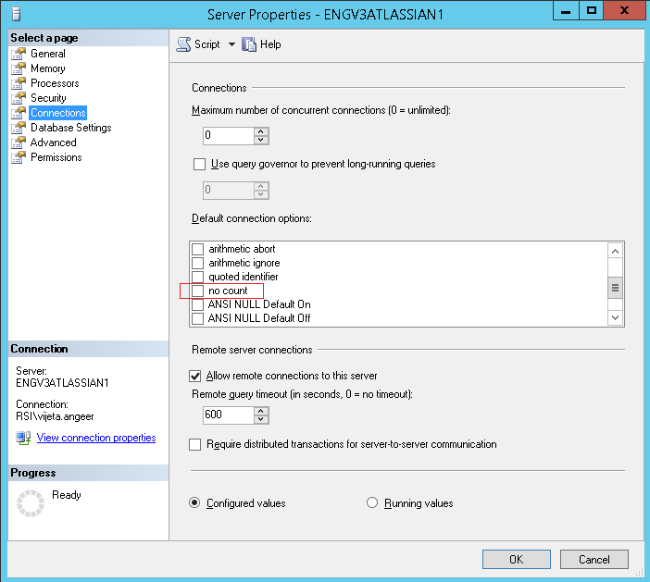

## **STASH_HOME Configuration**

* Create your Stash home directory, and then tell Stash where you created it by setting a STASH_HOME environment variable.

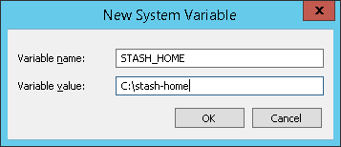

Restart your machine after set up the environment variable of stash.

* **Set the STASH_HOME Variable**

1. Right-click the **My Computer** icon on your desktop and select **Properties**.
2. Click on **Advanced** tab.
3. Click **on Environment Variables** button. Under **System Variables**, click New.
4. Enter the variable name as **STASH_HOME**.
5. Enter the variable value as STASH HOME directory path.
6. Click **OK**.
7. Click **Apply Changes**.

## **STASH installation**

* [Download STASH](http://www.atlassian.com/software/crowd/try.jsp).



* Run the **stash.exe** file of Stash & Click on **Next.**

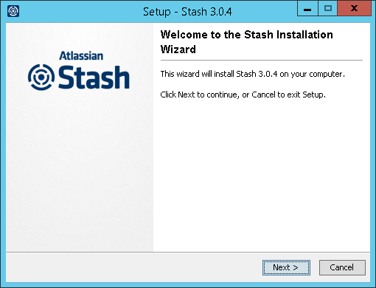

* Verify the Stash installation directory path & Click on **Next.**

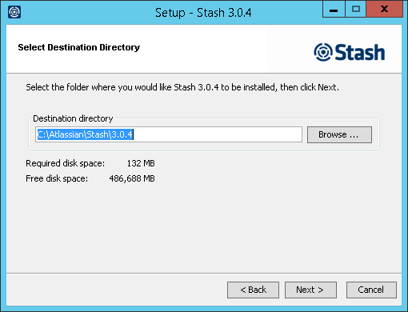

* Verify the Stash data directory path & Click on **Next.**

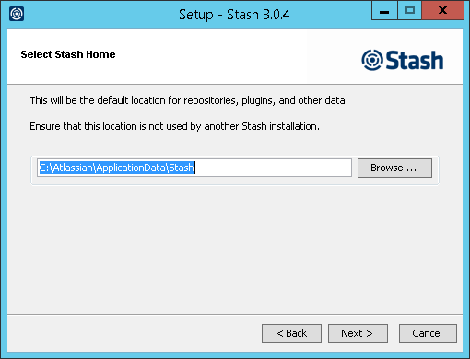

* Select **Use default ports** & Click on **Next.**

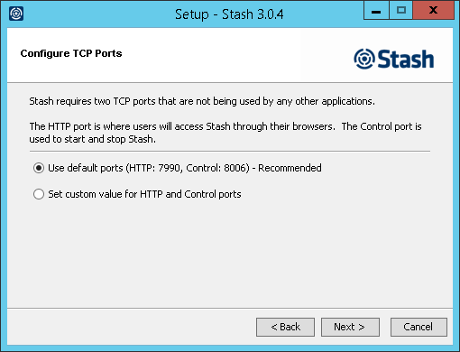

* Select **Install Stash as Service** & Click on **Next.**

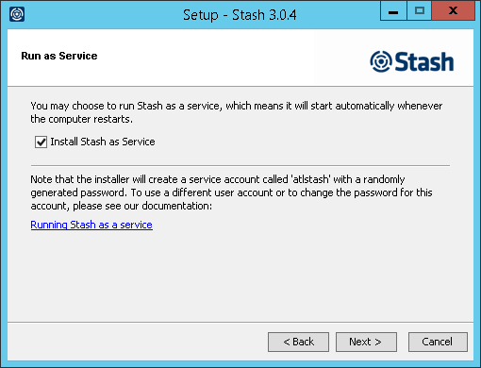

* Verify Installation Summary & Click on **Install.**

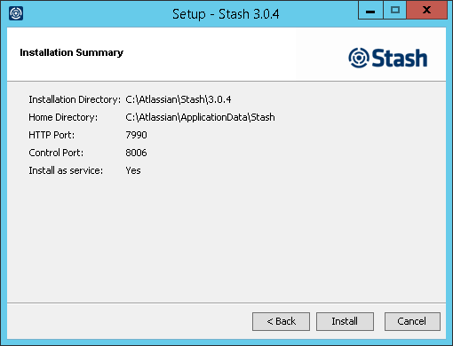

* Check mark on Launch Stash in browser & Click on **Finish.**

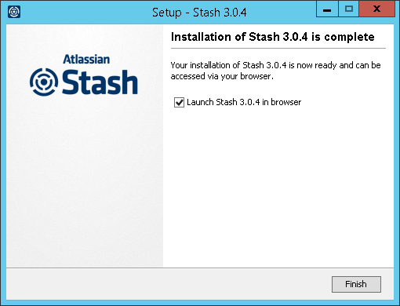

## **stash Configuration**

|  |  |
| --- | --- |
|  | |
| * Point a web browser at <http://localhost:7990/> * Select **External** Database & provide required details. Details as below.      * Provide Database configuration details & Click on **Next.**      * Generate license key from Atlassian site and provide the license key. Click on **Next.**      * Provide details of **Administrator** & Click on **Go to Stash.**      * **Login** with admin credential. | |
|  | |